Laboratory 04: Circuit Simulation
(Edit this document as needed)

Partner 1: _______________John Gonzalez_________

Partner 2: ____________Saaif Ahmed____________
Partner 3: _______________________________ (if needed)

Part A.1
Brief description of part A.1:
The objective of this part of the experiment is to utilize a function generator on the Analog Discovery Board and analyze how changing different elements of the wave function affects the output signal. Specifically the amplitude, VDC offset, frequency, and supply voltage.

Include an annotated image of your Oscilloscope measurements for the 1kHz, 200mV input signal. (e.g. Label frequency or period, amplitude). Refer to the lab about copy Oscilloscope plots into your report.

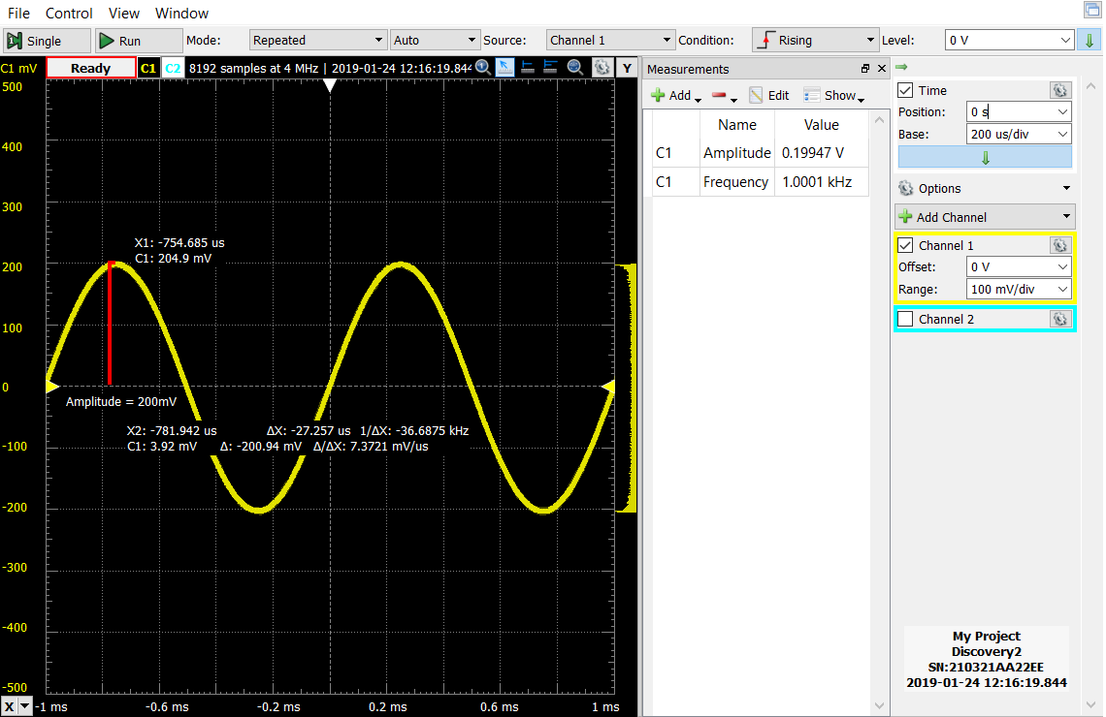

Keeping the same Oscilloscope settings, what changes did you see when the frequency was increased?

When the frequency was increased, the period decreases causing the waveform to come closer together. A larger frequency resulted in a larger amount of oscillations over a given time interval.

Changing the frequency, amplitude, and offset, generate a few Oscilloscope plots. On the plots annotate the parameters of interest, ie. indicate and label the amplitude, period, etc.

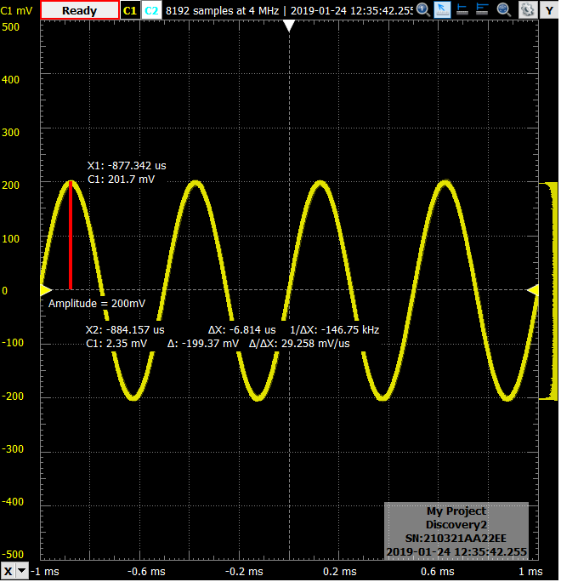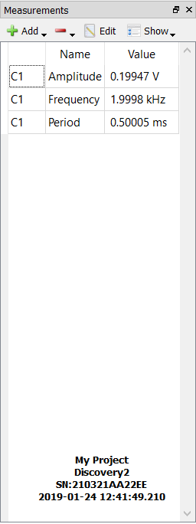
Changed frequency to 2 Khz.

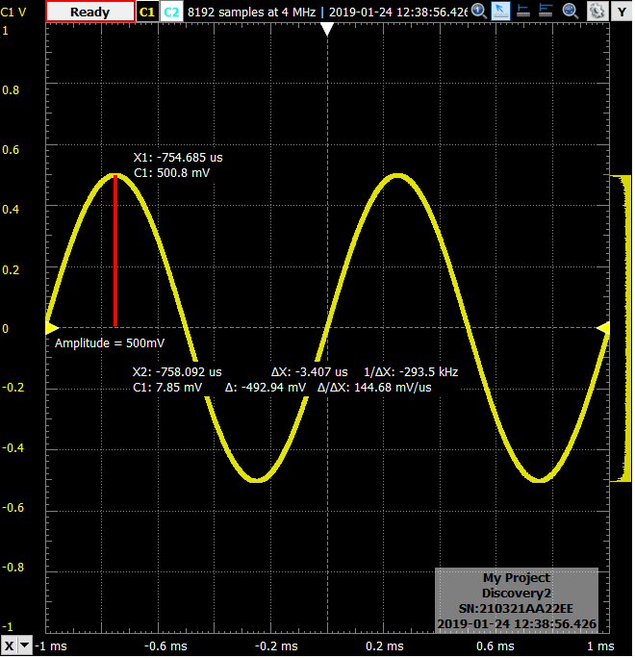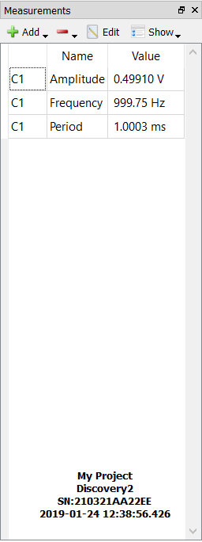
Changed amplitude to 500 mV.

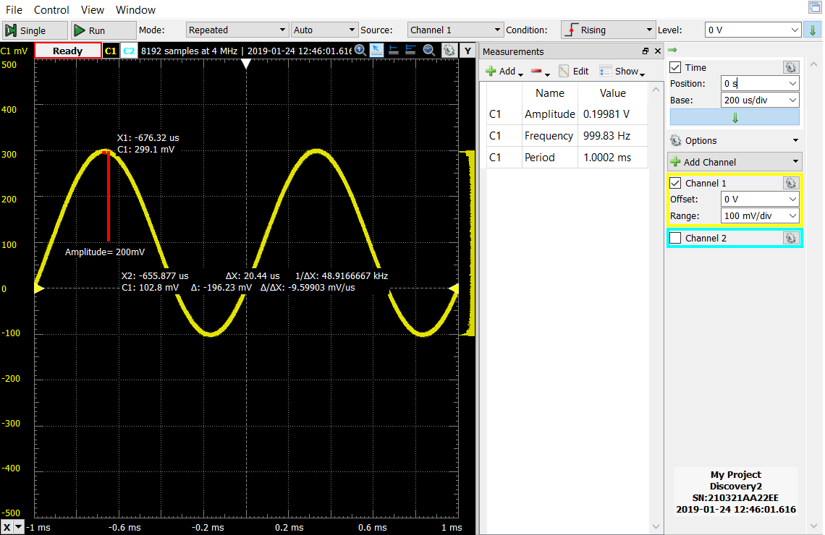
Changed Vdc offset to 100mv.

Part A.2
Brief description of Part A.2:
Determine a baseline for the human audible range of frequencies. By taking into account the resistance of the headphone wires, we can determine the approximate audible range for an average person. This was accomplished by lowering the supply voltage to a comfortable level and then increasing the frequency of the wave till it was inaudible.

What resistance value did you measure for your ear buds/earphones?
Resistance | 18Ω

What voltage amplitude did you find comfortable at 1kHz? (It is not necessary to have three partners, you can ignore extra lines.)

Partner 1 | 10mV
Partner 2 | 10mV
Partner 3 | V

For the voltage you found above, what frequency seemed the ‘loudest’?

Partner 1 | 17kHz
Partner 2 | 15kHz
Partner 3 | Hz

Did you notice any trends with regard to hearing range? There is a gender difference, with men typically having a reduced range relative to women.
https://en.wikipedia.org/wiki/Hearing_range

Both partners are male. However one is partner (John) is older than the other partner (Saaif). This may result in the difference of range of hearing.

Part B.1
Brief description of the experiment
In the previous lab, because our circuit was not ideal, we were not able to properly determine the results of a voltage divider circuit with large resistances. This lab utilizes a circuit simulator to display the theoretical results of a such a voltage divider, and to demonstrate the differences between and ideal and real circuit.

Sketch of the 1kΩ voltage divider circuit with oscilloscope input impedance.

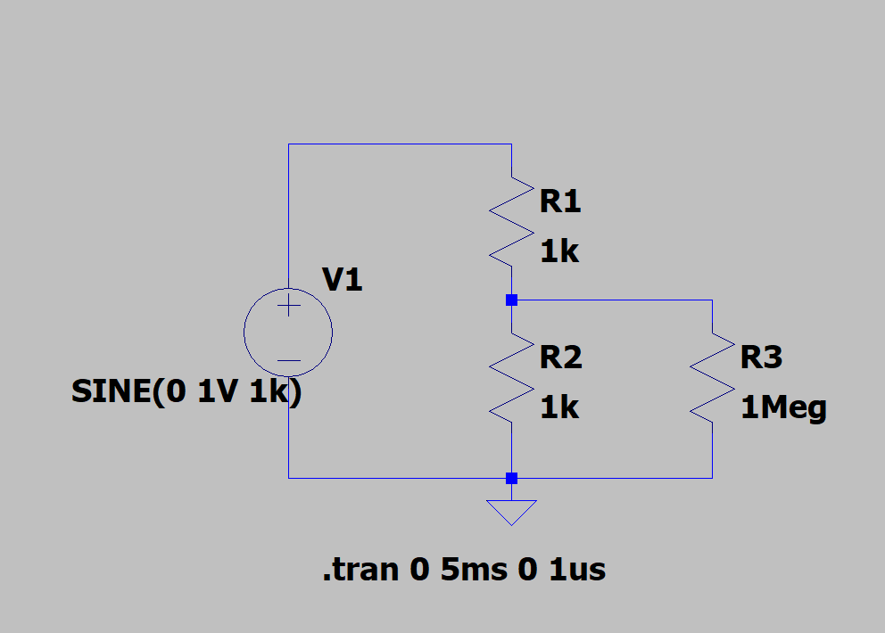

Voltage plots from the voltage divider with 1kΩ resistors, including the source voltage and the voltage across R2||R3. Use the “copy to clipboard” procedure described in the lab.

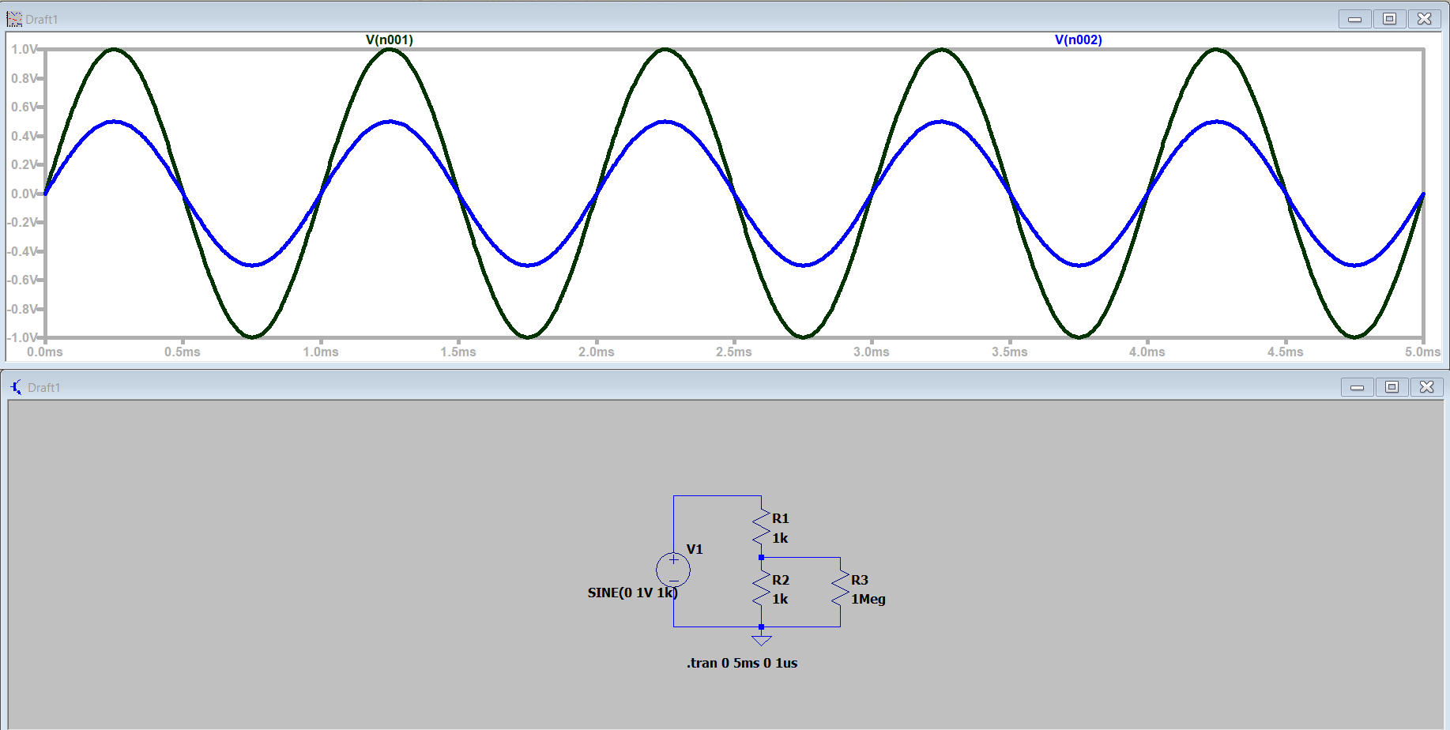
V(n001)=input voltage (black line)
V(n002)= output from voltage division(blue line)

Are the above simulation plots consistent with the results from the previous experiment?

The simulation plots are consistent with the previous experiment.
Sketch of the 1MegΩ voltage divider circuit with oscilloscope input impedance.

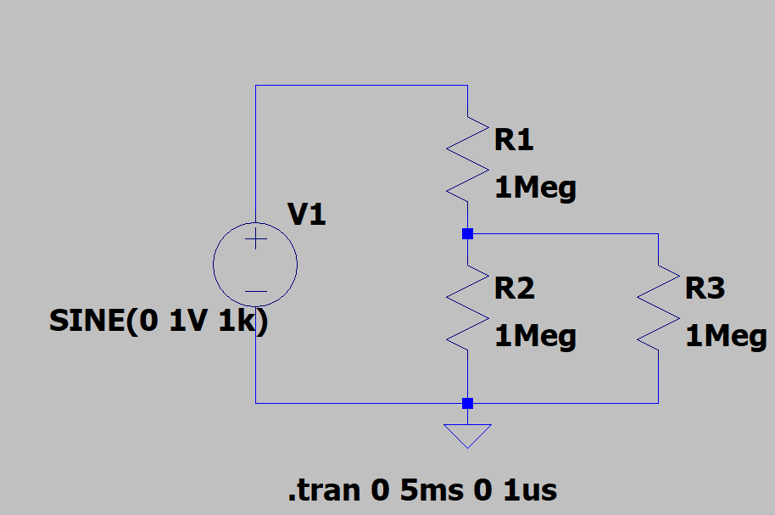

Voltage plots from the voltage divider with 1MegΩ resistors, including the source voltage and the voltage across R2||R3. Use the “copy to clipboard” procedure described in the lab.

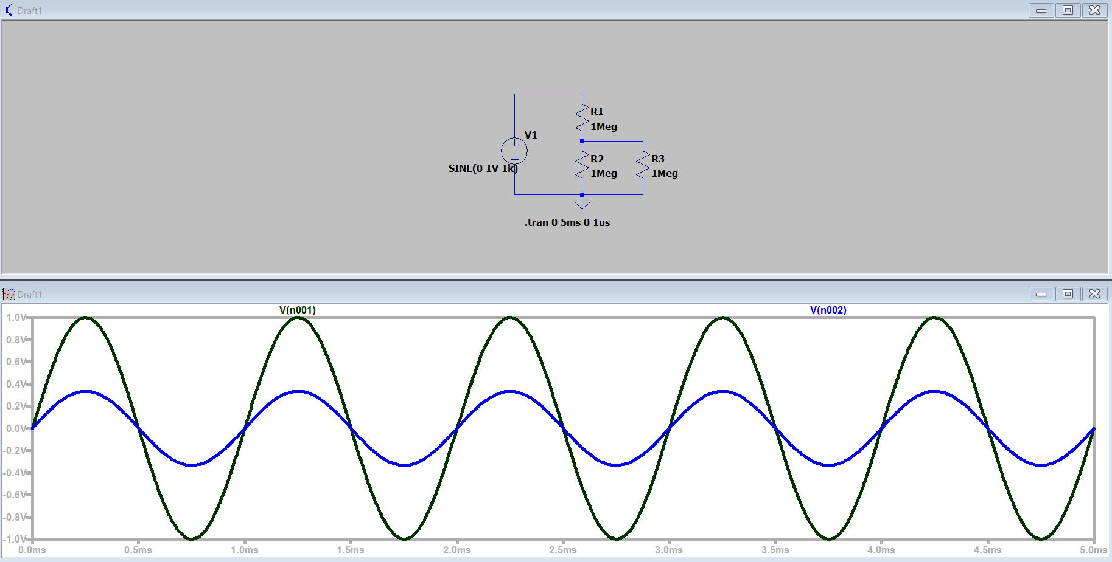

V(n001)= Source Voltage (black line)
V(n002)=Output Votlage (blue line)

Verification of results: TA/Instructor’s initials _________YL__________

Are the above simulation plots consistent with the results from the previous experiment?

The simulation plots are consistent with the results from the previous experiments.

Include several plots with the variations indicated in laboratory, ie. changes in frequency, changes in amplitude, changes in offset. For each plot, clearly provide a mathematical expression for the source. Refer to the laboratory introduction for a discussion on sinusoidal signals. Alternatively, visit the following link developed at Digilent.
https://learn.digilentinc.com/Documents/131#
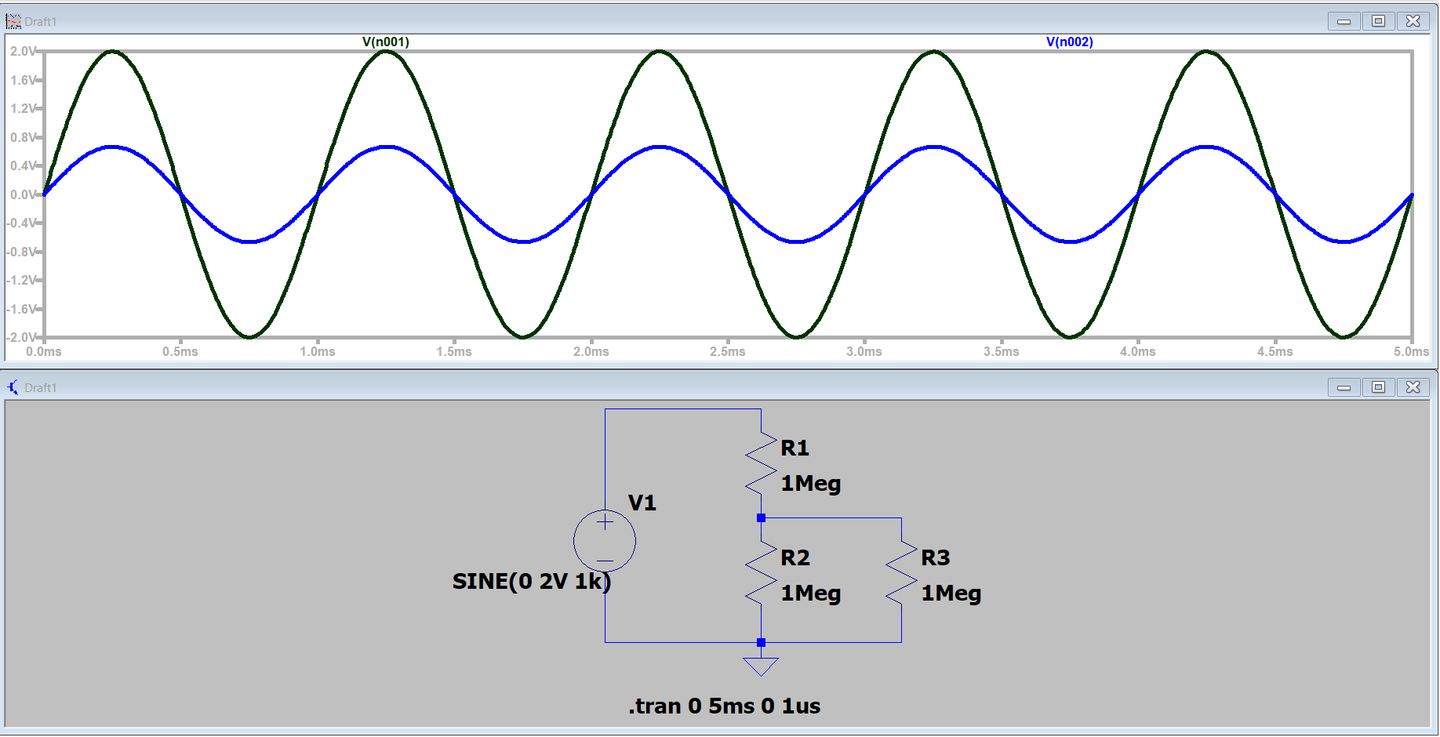
Amplitude changed to 2V: v(t)=2sin(2π(1000)t)

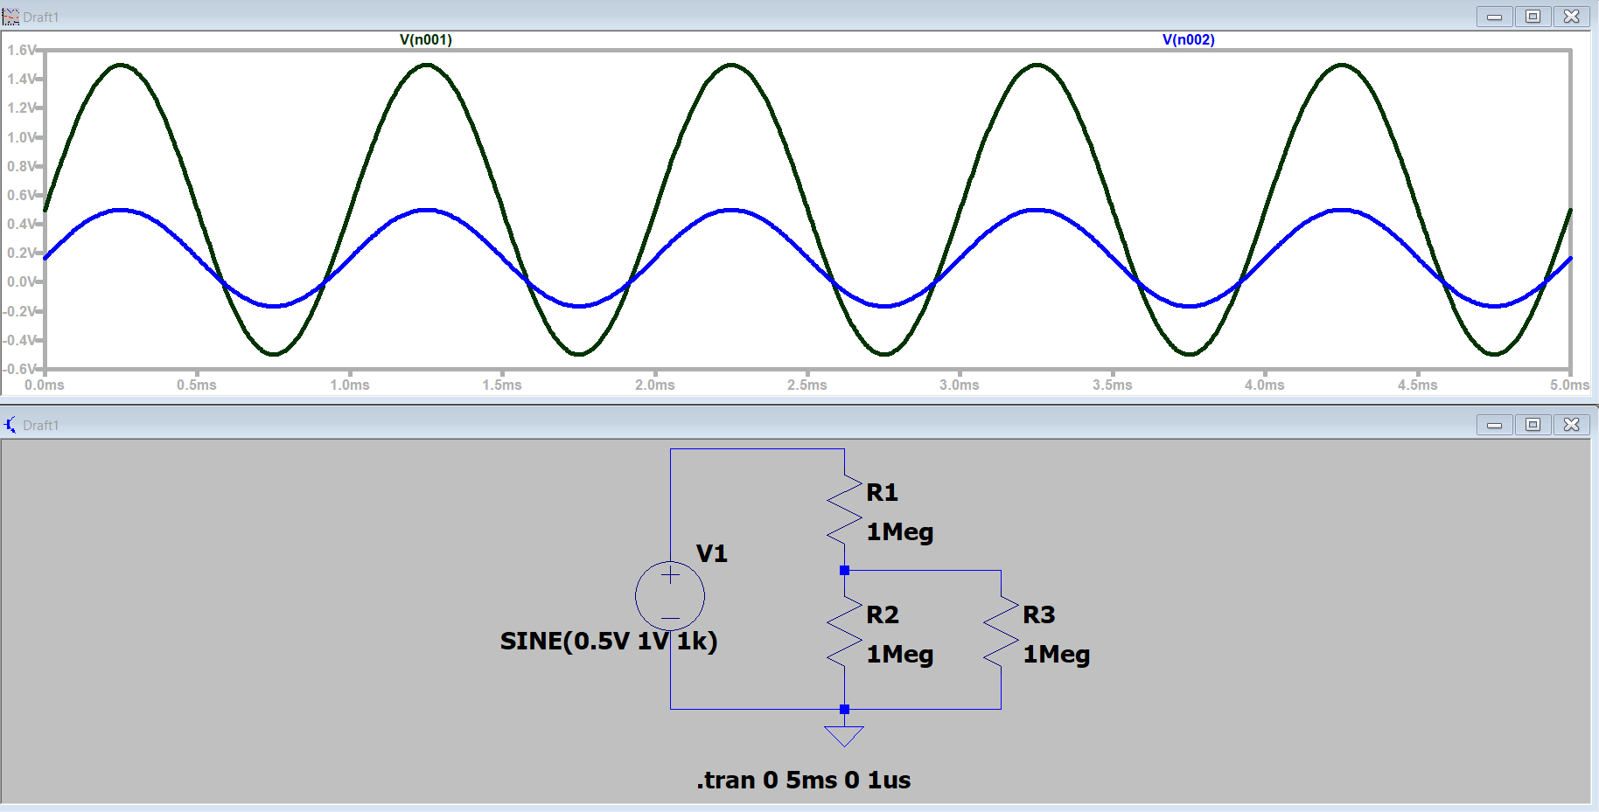
DC offset changed to 0.5V: v(t)=1sin(2π(1000)t)+0.5
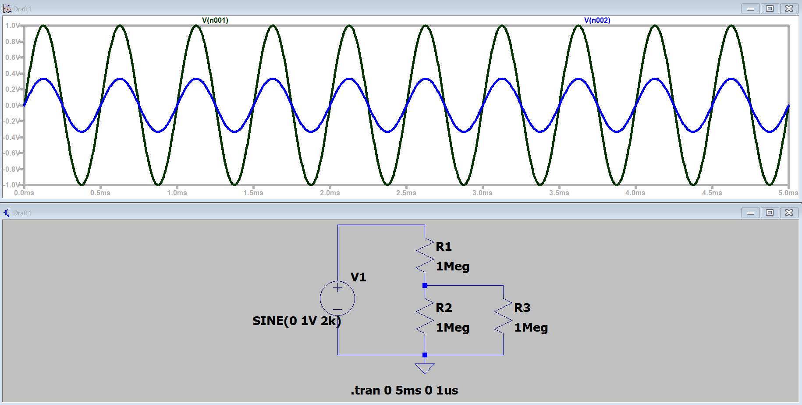
Frequency changed to 2kHz: v(t)=1sin(2π(2000)t)

